1
a) Are the following substances chemically pure or classed as mixtures? Put a tick in the correct box. (7)
Substance | Pure | Mixture
Air
Sea water
Glucose
Bromine
Distilled water
Milk
Sodium hydroxide solution
b) Are the following substances elements or compounds? Put a tick in the correct box. (5)
Substance | Element | Compound
Sodium (Na)
Water (H₂O)
Helium (He₂)
Bromine (Br₂)
Glucose (C₆H₁₂O₆)
c) Alloys, fuels and paints are all examples of formulations. Explain briefly what a formulation is. (2)

2
a) The diagram below shows a chromatography experiment used for separating inks.
From the diagram what are the following pointing to:
A = ____________________________________ (1)
B = ____________________________________ (1)
C = ____________________________________ (1)
b) Why is the start line drawn in pencil? (1)

c) What component is the mobile phase? (1)

d) What component is the stationary phase? (1)

e) After several minutes, the dots have moved up the paper.

i) Why does this happen? (2)

ii) Why do some move further than others? (2)

iii) Calculate the R_{f} values for the two dyes shown in the diagram below.
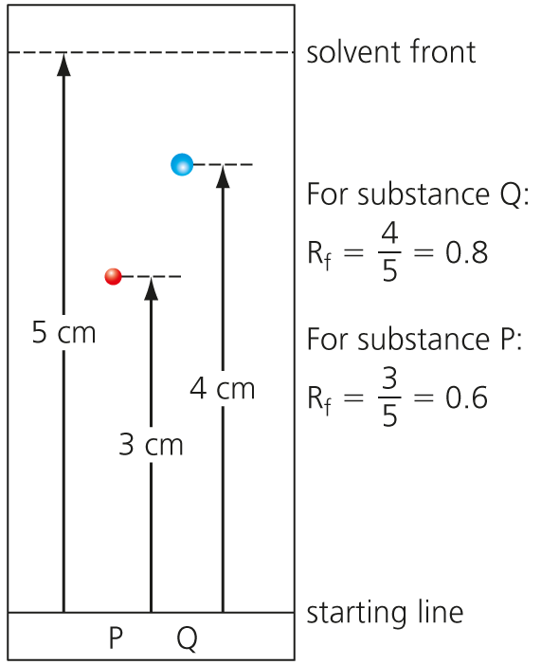
R_{f} for P ___________ (1)

R_{f} for Q __________ (1)

3
a) Below are various tests used to detect different gases.
 | Test | Result
A | Glowing splint | Relights
B | Lit splint | Squeaky pop
C | Bubble gas through limewater | Goes cloudy
D | Hold damp blue litmus paper in gas | Goes white
Give the correct letter of the test which is used to detect:
i) Hydrogen ________ (1)
ii) Chlorine ________ (1)
iii) Oxygen _______ (1)
iv) Carbon dioxide _________ (1)
b) Fill in the gaps in the table below for results of flame testing: (4)
Metal | Colour
Sodium
 | Green
Lithium
 | Lilac
c) Briefly state how a flame test is carried out. (2)

4 Sodium hydroxide can be used to identify Fe²⁺ ions.
a) Write the balanced chemical equation for the reaction that occurs with sodium hydroxide and iron II chloride. (3)

b) What is the colour of the precipitate formed? (1)

c) This reaction can be expressed in an ionic equation. Complete and balance the equation. (2)
___Fe²⁺(aq) + ____(OH)⁻(aq) → _________________
5
a) A student found four containers with no labels as the labels had fallen off the containers. The labels read: magnesium chloride, sodium chloride, magnesium sulfate, sodium sulfate.
Explain, by using chemical tests, how the student could distinguish between the four chemicals. (6)

b) What advantage has flame emission spectroscopy over a simple flame test? (2)

Total = 50

1
a)
Substance | Pure | Mixture
Air
Sea water
Glucose
Bromine
Distilled water
Milk
Sodium hydroxide solution
(7)
b)
Substance | Element | Compound
Sodium (Na)
Water (H₂O)
Helium (He)
Bromine (Br₂)
Glucose (C₆H₁₂O₆)
(5)
c) A formulation is a mixture that has been designed as a useful product. (2)
2
a) A = (chromatography) paper (1); B = beaker/jar/container (1); C = water/solvent (1)
b) Ink would ‘run’/smudge/pencil doesn’t. (1)
c) Solvent (1)
d) Paper (1)
e)
i) Substances that have a stronger attraction to the solvent move quickly and travel a long way up the paper. Substances that have a stronger attraction to the paper move slowly and only travel a short distance up the paper. (2)
ii) Some have stronger attraction to the solvent than the paper. (2)
iii) R_{f} for P = = 0.6; R_{f} for Q = = 0.8 (2)

3
a)
i) B (1)
ii) D (1)
iii) A (1)
iv) C (1)
b)
Metal | Colour
Sodium | Yellow
Copper | Green
Lithium | Crimson
Potassium | Lilac
(4)
c) Dip nichrome wire/splint into acid then into sample then into flame. (2)
4
a) 2NaOH + FeCl₂ → Fe(OH)₂ + 2NaCl (LHS = 1, RHS = 1, balance = 1)
b) Green (1)
c) Fe²⁺(aq) + 2(OH)⁻ (aq) → Fe(OH)₂(s) (balance = 1 mark, (s) = 1)
5
a)
Marks
6–5 | At least three different points well expressed
4–3 | A couple of points mentioned
2–1 | Not much detail

- Flame test
- Na = yellow flame,
- Mg = no colour
- Add a few drops nitric acid.
- Add silver nitrate.
- White precipitate = chloride ions
- Add barium chloride.
- White precipitate = sulfate ion
b) Flame emission spectra can measure concentrations of ions in solutions. (2)
Total = 50

